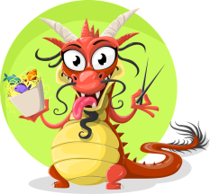
Dragon song _ To the tune of merrily we go a long-https://youtube .com/watch?v=by5sTzh67fU
See the dragons dance and prance, dance and prance, dance and prance
See the dragons dance and prance on Chinese New year’s day .

See the dragons hop, hop, hop, hop, hop, hop, hop, hop, hop
See the dragons hop, hop, hop on Chinese New year’s day .

See the dragons shake their tails, shake their tails, shake their tails,
See the dragons shake their tails on Chinese New year’s day.

See the dragons turn around, turn around, turn around.
See the dragons turn around on Chinese New Year’s day.

See the dragons go to sleep, go to sleep, go to sleep,
See the dragons go to sleep on Chinese New Year’s day.

