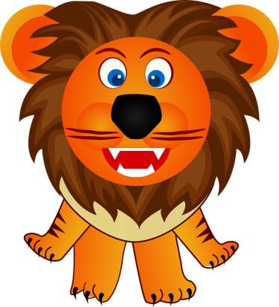
Leo the Lion
Leo the Lion
Is the king of the jungle
His jaws are open wide!
Roar!
Leo the lion
Is the king of the jungle
And when you hear him roaring it’s bound to be a warning
That you better run away and hide!
Roar!

