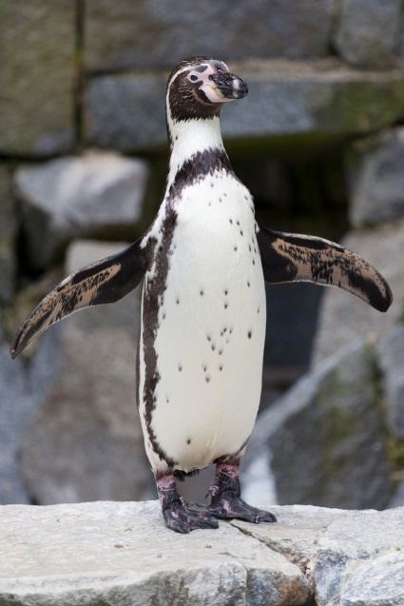
I’m a little Penguin
I’m a little Penguin, black and white,
I waddle to the left and I waddle to the right,
I cannot fly but I can swim
So I waddle to the water and jump right in.

