Mathematics in Year 5
- Count forwards and backward with positive and negative numbers through zero.
- Count forwards/backwards in steps of powers of 10 for any given number up to 1,000,000.
- Compare and order numbers up to 1,000,000. Compare and order numbers with 3 decimal places.
- Read Roman numerals to 1,000.
- Identify all multiples and factors, including finding all factor pairs. Use known tables to derive other number facts.
- Recall prime numbers up to 19. Recognise and use square numbers and cube numbers.
- Recognise place value of any number up to 1,000,000.
- Round any number up to 1,000,000 to the nearest 10, 100, 1000, 10,000 or 100,000.
- Round decimals with 2 decimal places to nearest whole number and 1 decimal place.
- Add and subtract numbers with more than 4-digits using formal written method.
- Use rounding to check answers.
- Multiply and divide 4-digits by 1-digit/ 2-digit. Multiply & divide whole numbers & decimals by 10, 100 and 1,000
- Recognise and use thousandths.
- Recognise mixed numbers and improper fractions and convert from one to another.
- Multiply proper fractions and mixed numbers by whole numbers. Identify and write equivalent fractions.
- Solve time problems using timetables and converting between different units of time.

Y5 Addition | Y5 Subtraction
- Continue to use columnar addition, adding numbers with more than 4 digits.  3 2 8 7 9  + 3 5 9 8 7  6 8 8 6 6  - Addition of money and decimals.  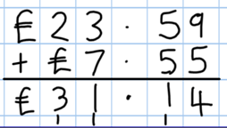  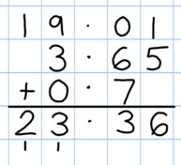 | - Continue with compact columnar subtraction, including subtraction of decimals.  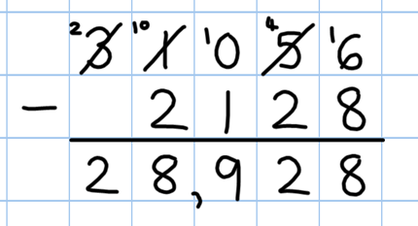  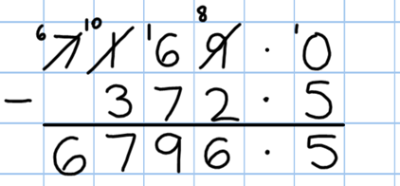  - Use rounding to check answers to calculations and to determine, in the context of a problem, levels of accuracy.

Y5 Multiplication | Y5 Division
- Recall and use multiplication tables up to 12x12  (Including multiplying by 0 and 1).  - Continue to practise short multiplication.  - Use Grid Method to introduce long multiplication.  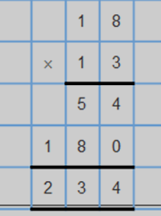  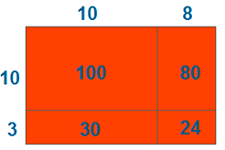 | - Consolidate the use of the formal written method of short division.  