THE WILLOWS PRIMARY SCHOOL



ENGLISH POLICY

Safeguarding Statement

The school is committed to safeguarding children and promoting the welfare of children and young people and expects all staff and volunteers to share this commitment.

Author: Headteacher/ENCO

Date: October 2026

Review Date: September 2027

Date approved:

English is a core subject within the National Curriculum. An important part of all our teaching is to develop pupils’ ability to use language to think, explore, organise and communicate meaning in a range of different situations.

Aims
- To enable pupils to develop the foundational skills needed in order to access all other curriculum subjects
- To enable pupils to acquire the communication and language skills to express themselves correctly and appropriately.
- To enable pupils to read and write accurately, fluently and with understanding.
- To provide real contexts for language learning across the curriculum.
- To teach pupils the vocabulary they need to develop their reading, writing and spoken language skills.
- To encourage pupils to widen their vocabulary and knowledge of words – developing an interest in words, their meaning and a growing vocabulary.
- To ensure pupils develop a clear understanding of how to construct sentences based on Standard English both orally through communication and speech as well as in writing.

Curriculum Organisation
Teachers work together to plan the overall English programme, ensuring balance and progression across the school, using the National Curriculum objectives as the core scheme of work. This is supported by the long term overviews and school unit maps planning documents.

Each year group uses the long term unit overview as their basis for planning and teachers work together in teams to develop the required units of work and complete their weekly plans. These units identify appropriate teaching and learning strategies required to cover the teaching objectives and ensure the needs of all pupils are met within a variety of organisational learning.

Spoken language
Spoken language underpins the development of reading and writing. The quality and variety of language that pupils hear and speak is vital for developing their vocabulary and grammar and their understanding for reading and writing. Teachers plan for the continual development of pupils’ confidence and competence in spoken language. Pupils are taught to explain their understanding of books and other reading, and to prepare their ideas before they write. They are supported in making their thinking clear to themselves as well as to others. Pupils should also be taught to understand and use the conventions for discussion and debate.
Pupils should be taught to:
- listen and respond appropriately to adults and their peers
- ask relevant questions to extend their understanding and knowledge
- use relevant strategies to build their vocabulary
- articulate and justify answers, arguments and opinions
- give well-structured descriptions, explanations and narratives for different purposes, including for expressing feelings
- maintain attention and participate actively in collaborative conversations, staying on topic and initiating and responding to comments
- use spoken language to develop understanding through speculating, hypothesising, imagining and exploring ideas
- speak audibly and fluently with an increasing command of Standard English
- participate in discussions, presentations, performances, role play and debates
- consider and evaluate different viewpoints, attending to and building on the contributions of others
- select and use appropriate registers for effective communication.

Spoken language and listening experiences at The Willows Primary School include:
- Role-play, hot-seating
- Group discussion and interaction – collaborative group work
- Presentations
- Speaking for different purposes and audiences
- Listening and responding
- Debating

ECAT (Every Child A Talker) - We are an ECAT school.
Every Child a Talker (ECAT) is designed to help practitioners and parents create a developmentally appropriate, supportive and stimulating environment in which children can enjoy experimenting with and learning language. Through everyday, fun and interesting experiences which reflect children’s interests, ECAT encourages early language development right from the outset, extending children’s vocabulary so that before they start school, children are confident and skilled communicators.

Reading
The programmes of study for reading at key stages 1 and 2 consist of two dimensions:
- word reading
- comprehension (both listening and reading).

It is essential that teaching focuses on developing pupils’ competence in both dimensions; different kinds of teaching are needed for each.

Skilled word reading involves both the speedy working out of the pronunciation of unfamiliar printed words (decoding) and the speedy recognition of familiar printed words. Underpinning both is the understanding that the letters on the page represent the sounds in spoken words. This is why phonics should be emphasised in the early teaching of reading to beginners (i.e. unskilled readers) when they start school. (please also refer to Early Reading policy)

Good comprehension draws from linguistic knowledge (in particular of vocabulary and grammar) and from a knowledge of the world. Comprehension skills develop through pupils’ experience of high-quality discussion with the teacher, as well as from reading and discussing a range of stories, poems and non-fiction.

All pupils are encouraged to read widely across both fiction, non-fiction and poetry to establish an appreciation and love of reading, and to gain knowledge across the curriculum. Reading widely and often increases pupils’ vocabulary because they encounter words they would rarely hear or use in everyday speech. Reading also feeds pupils’ imagination and opens up a world of wonder and joy for curious young minds.

It is essential that, by the end of their primary education, all pupils are able to read fluently, and with confidence.

Reading experiences at The Willows Primary School include:
- Teachers reading to pupils
- Reading Fluency
- Modelled reading
- Shared reading and choral reading
- Group reading and paired reading
- Individual reading and independent reading
- Research and reading in other subjects
- Reading for pleasure
- Wider reading opportunities – accessing the school library

- Comprehension activities

Reading experiences are planned using the year group curriculum overviews. Class novels are read regularly and displayed within the classroom.

In KS1, daily reading practice sessions are planned in addition to phonics and literacy lessons.
Reading practice texts are chosen appropriate to age, ability and interest. Shared, modelled, choral, group, individual and paired reading should improve fluency, comprehension and response. There is a continued focus on the use and application of phonics for struggling readers, including diagnostic assessment/intervention where necessary to enable them to tackle unfamiliar words.

Why is vocabulary an important component of reading?
Vocabulary is the range of words a child is able to understand and use in context. Children’s vocabularies grow as they read and are introduced to new words. You can only take meaning from words you understand. Children with broader vocabularies are more confident when reading challenging or unfamiliar material. When they encounter unknown words, they can figure it out based on context clues or resemblance to familiar pieces of vocabulary.

Reading Fluency Sessions
Children across KS2 have daily reading sessions in addition to their literacy lesson.
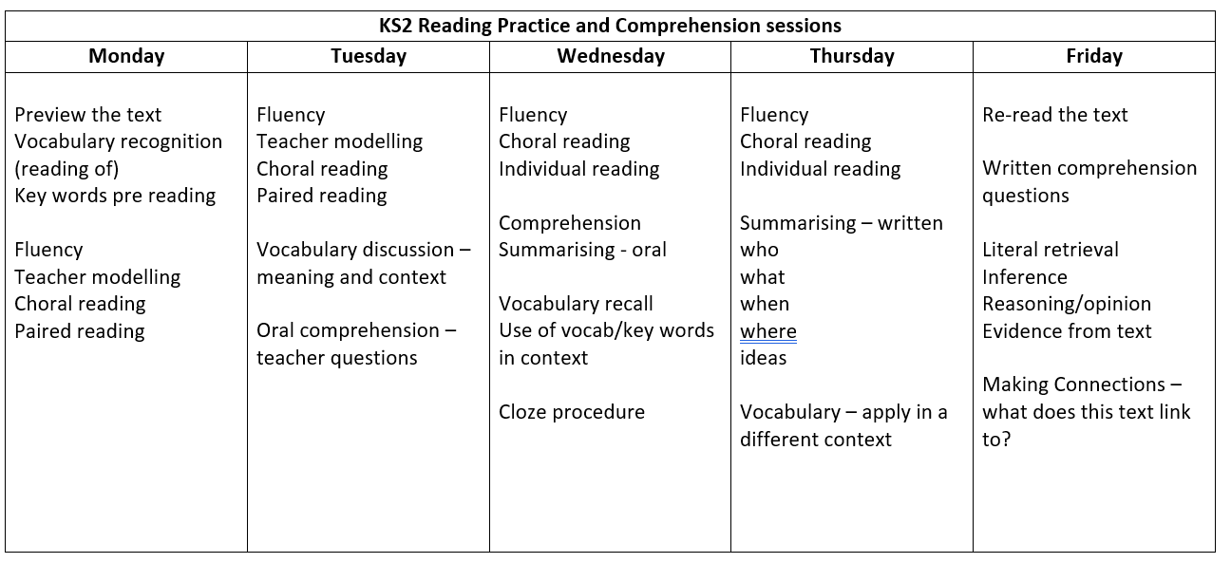

Why is fluency an important component of reading?
Fluency is the ability to read with speed, understanding, and accuracy. It’s the skill that allows us to ‘follow’ a text, picture its descriptions, and hear the auditory expression of words in our heads even when reading silently. Fluency is what lets children feel the ‘flow’ of a text. Fluency and comprehension are closely tied. A student cannot fully understand the meaning and ideas behind a text without the ability to read it fluently.

Why is comprehension an important component of reading?
Comprehension is a student’s understanding of the information being imparted by a text, such as: who, what, when, where, ideas and meanings. Comprehension allows children to draw meaning and information from a text, and it also transforms reading from a purely functional activity into one that inspires thought and feeling.

Text Immersion
In KS2, we use the text immersion model where the children are immersed within the text type before writing in order to provide a clear understanding of the text type, access to relevant contextual vocabulary and a model for writing. There is regular text immersion in every class to enrich comprehension and response. Reading provides models for writing with regular opportunities for oral/written comprehension of text.

Writing
Writing is a foundational skill. The programmes of study for writing at key stages 1 and 2 consist of two dimensions:
- transcription (spelling and handwriting)
- composition (articulating ideas and structuring them in speech and writing).

It is essential that teaching develops pupils’ competence across both these two dimensions. In addition, pupils should be taught how to plan, revise and evaluate their writing.

Writing down ideas fluently depends on effective transcription: that is, on spelling quickly and accurately through knowing the relationship between sounds and letters (phonics) and understanding the morphology (word structure) and orthography (spelling structure) of words.

Effective composition involves forming, articulating and communicating ideas, and then organising them coherently for a reader. This requires clarity, awareness of the audience, purpose and context, and an increasingly wide knowledge of vocabulary and grammar. Writing also depends on fluent, legible and, eventually, speedy handwriting.

Writing experiences at The Willows Primary School include:
- Modelled writing
- Shared writing
- Drafting, and editing
- Guided writing

- Independent writing
- Writing in other subjects
- Publishing and presenting writing

Writing experiences are planned using the year group curriculum overviews for English.

Vocabulary
Teachers plan opportunities to show pupils how to understand the relationships between words, how to understand nuances in meaning, and how to develop their understanding of, and ability to use, figurative language. They also teach pupils how to work out and clarify the meanings of unknown words and words with more than one meaning.

Teaching experiences will be structured to
- Support language acquisition and widen children’s vocabulary and their understanding of the meaning of new words
- Ensure reading experiences widens the recognition, reading and understanding of a wide range of vocabulary
- Ensure discussion and dialogue develops their an understanding of new vocabulary so that it has meaning and can be integrated into their own use of language (when speaking and writing)
- Develop support and intervention for children with EAL and additional language needs
- Develop children’s use and understanding of subject specific vocabulary in order to enable them to know more and remember more
- Develop subject specific vocabulary to aid the retention of knowledge across the curriculum by promoting the use of subject specific word mats, word banks, key topic word lists

Grammar
Explicit knowledge of grammar is very important, as it gives us more conscious control and choice in our language. Once pupils are familiar with a grammatical concept, they should be encouraged to apply and explore this concept in the grammar of their own speech and writing. It is important that pupils learn the correct grammatical terms in English and that these terms are integrated within teaching. Pupils should be taught to control their speaking and writing consciously and to use Standard English.

Grammar is taught both as a discrete session and as part of literacy lessons. Year group grammar overviews identify the key aspects of grammar that should be taught discretely and those aspects which must be taught within literacy lessons as they are relevant to the text type and purpose for writing. Children will be given opportunities to apply the taught grammar skills within their extended writing as well as within specific activities.
Discrete Grammar sessions are timetabled on a regular basis and planned using the year group overview which focuses on the key grammar concepts within the NC Programme of Study – direct teaching is used to ensure children are taught new concepts and the associated correct grammatical vocabulary

Grammar Teaching will
- Include opportunities to practice the taught concept in isolation and then apply it within the context of sentences/their writing
- Include opportunities to review and revisit the taught concept in isolation and within the context of sentences/their writing
- Include opportunities for children to complete practice test style questions to ensure that they can apply their knowledge in specific contexts
- Allow teachers to make informal day to day assessments to identify how secure pupils are with the taught concept both during immediate teaching sequences but also over time when concepts are revisited.

Spelling
Spelling is taught both as discrete sessions and as part of literacy lessons. Children will be given opportunities to learn whole word spelling and spelling patterns as well as the features of spelling. Spellings will always be taught and practiced in context and there is a constant focus on enabling the children to apply the taught spellings/patterns within their extended writing as well as within specific activities.

Spelling lessons follow a daily structure to enable children to secure spellings and key words using repeated practice as the main approach to learning.

Children are taught to
- secure the sequence of letters in words (using letter names)
- recognise the whole word and secure the shape of words
- replicate spellings through repeated practice
- write the words from a model to secure automaticity in writing through muscle memory and handwriting skills
- correct misspelt words and identify missing letters in words

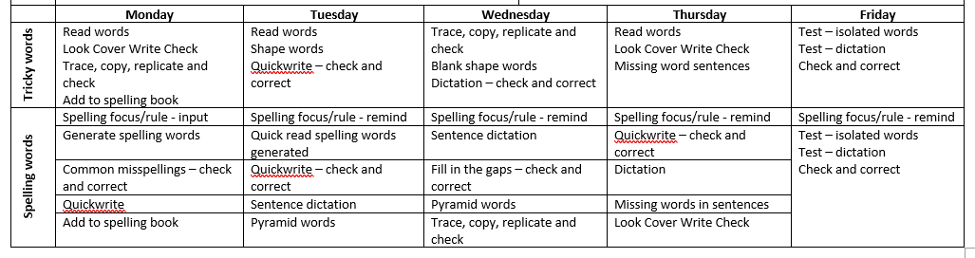

Word mats, key word lists and dictionaries are available in every classroom to support spelling. Proof-reading and editing skills are taught to enable the children to correct spellings in their own writing. Teachers identify words that need to be corrected as part of the marking process.

Special Needs and Classroom Support
The class teacher will ensure that pupils have work planned to meet their individual needs. Teaching assistants will provide support for children’s learning as directed by their class teacher. There are intervention programmes in place for pupils who require regular, additional support with literacy.

Monitoring and Assessment

Pupils’ skills, knowledge, understanding, progress and attitude will be assessed regularly and children will be monitored both individually and in groups as part of ongoing teacher assessment. Regular assessment will inform next steps planning for pupils’ needs and ensure progression for all. Success ladders are set for each unit of writing, based on the genre and the writing skills that are the focus for that unit. Summative assessments are carried out at the end of each term and formal statutory testing takes place at the end of KS2 in line with National Curriculum assessment requirements. Parents are provided with annual written reports to ensure they are informed of progress, including strengths and weaknesses. Parents are invited to attend parents’ evenings throughout the academic year.

Cross-Curricular Opportunities

A cross-curricular approach is developed through IPC subjects, science, computing and RE, where links are made to ensure children can apply their literacy skills in a relevant, meaningful and purposeful way. Writing experiences are planned using the year group curriculum overviews for English – these overviews identify appropriate and purposeful cross-curricular links in writing.

THE WILLOWS PRIMARY SCHOOL


SUBJECT LEADER
Roles & Responsibilities

To monitor the subject and be able to comment on
- Standards throughout the school
- Progression of skills throughout the school
Gather evidence on the quality of provision within the subject through monitoring/evaluation
- Lesson observations/learning walks
- Work/book scrutiny
- Planning scrutiny
- Pupil/staff discussion
Monitoring activities must be agreed with HT before they take place and feedback from these activities should be discussed and agreed with HT before it is given to staff
To be able to identify the quality of provision in the subject
- Know the strengths and weaknesses of the subject
- Know the development priorities for the subject as detailed in the SDP
- Know how the SDP priorities for the subject are being addressed
To develop secure subject knowledge and keep up to date with developments in the subject from EYFS, through KS1 and across KS2
To audit and maintain subject specific resources so that the subject can be successfully delivered throughout the school
- Order replacement/new resources in liaison with HT
Report on your subject to the HT
- Verbally at meetings, when requested
- Through the end of year co-ordinator report
Co-ordinate Governor visits, when requested, following liaison with the HT
Maintain CPD of yourself and other staff with a focus on your subject area
- Feedback to other staff on CPD undertaken
- Lead staff meetings and plan INSET when requested
Maintain the subject policy for the school
- Review the policy as per the policy review schedule
- Liaise with staff in terms of reviewing the policy – amend/distribute the policy accordingly
To advise and assist staff with the teaching and learning of the subject
Maintain a Subject Leader file
In line with HT management of teacher workload, subject leaders should not request additional work from staff unless agreed by HT beforehand

