THE WILLOWS PRIMARY SCHOOL

HANDWRITING POLICY

Safeguarding Statement

The school is committed to safeguarding children and promoting the welfare of children and young people and expects all staff and volunteers to share this commitment.

Author: Headteacher

Date: May 2022

Review Date: May 2024

Handwriting
Handwriting is a means of recording language on paper. It is an important life skill as a functional tool for expressing language and as part of self-image and expression of personality. Despite the increased use of computers for writing, the skill of handwriting remains important in education, employment and in everyday life. Writing also depends on fluent, legible and, eventually, speedy handwriting.’

As a school, we recognise that children’s ability to write well for the rest of their lives, depends on firm foundations of taught skills in their primary years.

Our aims in teaching handwriting are:
For all children to learn and practise appropriate and effective handwriting skills at each stage of development, continually working towards mature handwriting which is:
- Legible
- Presentable
- Comfortable
- Fluent
- Flexible
- Automatic
- Sustainable

Our whole school handwriting style is cursive letter formation which can then be easily joined when the children are able to master this skill. We do not teach/use lead in strokes but do ensure that the lead out stroke on appropriate letters is taught and secured at an early age.

A curisive letter formation style is taught and modelled from early years through to Y6. When teaching individual letter formation, the letters will include lead out strokes (ready for joining). Letters should be formed as folows

Lead out Strokes – no ascenders or descenders, all sit on the line
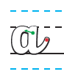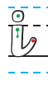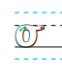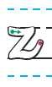
Lead out Strokes – with ascenders, all sit on the line
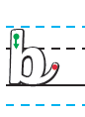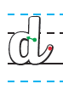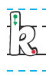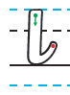

No lead out strokes – with descenders that hang below the line
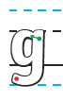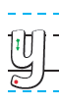
Lead out strokes – with descenders that hang below the line
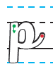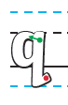
No lead out strokes – with an ascender and descender
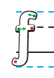
No lead out strokes – no ascenders or descenders, all sit on the line
Models of writing throughout the school will use cursive letter formation or a joined cursive writing style.
There are many benefits to teaching cursive handwriting.
- Help letter mix-ups: There are many letters that can be tricky to understand when your students are first learning letter formation. These include 'p', 'q' 'b' and 'd' that can each be written incorrectly backwards or upside down. By encouraging your students to use cursive formation, these mistake can be reduced. This is especially useful for dyslexic students, who may be prone to making these errors in letter formation.
- Increase concentration in writing: By reducing the amount of times the pen is lifted from the page, you might find that your students are able to write more fluidly, expressing their creative ideas continuously.
- Faster writing: One of the great reasons that teachers and students should learn to write in cursive styles is because it is actually much faster than writing in print by printing each letter individually. Because the cursive writing letters are connected, children lift their pen less frequently, which cuts down on time spent forming the letters.
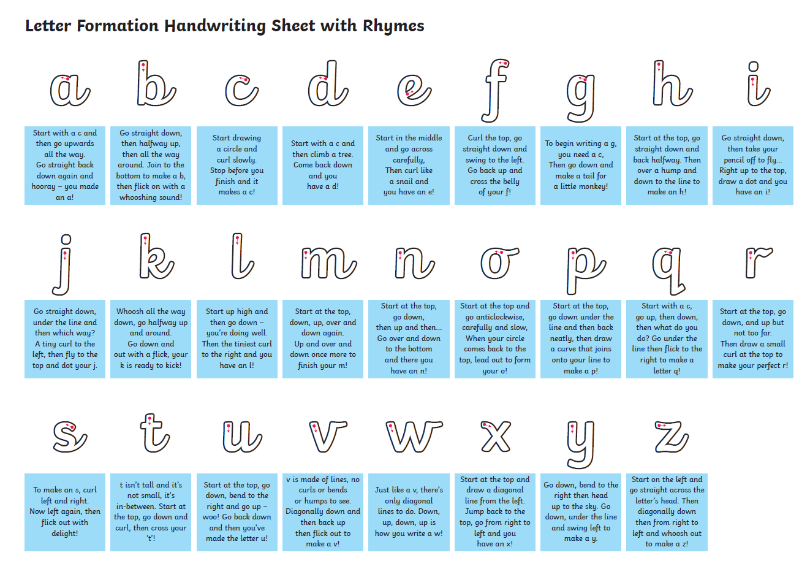

3 and 4 year olds will be learning to write some letters accurately

Help children to learn to form their letters accurately. First, they need a wide-ranging programme of physical skills development, inside and outdoors. Include large-muscle co-ordination: whole body, leg, arm and foot. Plan for small muscle co-ordination: hands and fingers. Children also need to know the language of direction (‘up’, ‘down’, ‘round’, ‘back’, etc)

Children in reception will be learning to form lower-case and capital letters correctly

Teach formation as they learn the sounds for each letter using a memorable phrase, encouraging an effective pencil grip. When forming letters, the starting point and direction are more important at this stage than the size or position of the letter on a line. Correct pencil grip is crucial at this stage as learned habits become ingrained and it is very difficult to establish new ones over time.

Handwriting – Year 1
Pupils should be taught to:
- sit correctly at a table, holding a pencil comfortably and correctly
- begin to form lower-case letters in the correct direction, starting and finishing in the right place
- form capital letters
- form digits 0-9
- understand which letters belong to which handwriting ‘families’ (ie letters that are formed in similar ways) and to practise these

Notes and guidance (non-statutory)
Handwriting requires frequent and discrete, direct teaching. Pupils should be able to form letters correctly and confidently. The size of the writing implement (pencil, pen) should not be too large for a young pupil’s hand. Whatever is being used should allow the pupil to hold it easily and correctly so that bad habits are avoided. Left-handed pupils should receive specific teaching to meet their needs.

Handwriting – Year 2
Pupils should be taught to:
- form lower-case letters of the correct size relative to one another
- start using some of the diagonal and horizontal strokes needed to join letters and understand which letters, when adjacent to one another, are best left unjoined
- write capital letters and digits of the correct size, orientation and relationship to one another and to lower-case letters
- use spacing between words that reflects the size of the letters

Notes and guidance (non-statutory)
Pupils should revise and practise correct letter formation frequently. They should be taught to write with a joined style as soon as they can form letters securely with the correct orientation.

Handwriting – Years 3 and 4
Pupils should be taught to:
- use the diagonal and horizontal strokes that are needed to join letters and understand which letters, when adjacent to one another, are best left unjoined
- increase the legibility, consistency and quality of their handwriting, [for example, by ensuring that the downstrokes of letters are parallel and equidistant, and that lines of writing are spaced sufficiently so that the ascenders and descenders of letters do not touch]

Notes and guidance (non-statutory)
Pupils should be using joined handwriting throughout their independent writing. Handwriting should continue to be taught, with the aim of increasing the fluency with which pupils are able to write down what they want to say. This, in turn, will support their composition and spelling.

Handwriting and presentation – Years 5 and 6
Pupils should be taught to:
- write legibly, fluently and with increasing speed by:
  - choosing which shape of a letter to use when given choices and deciding whether or not to join specific letters
  - choosing the writing implement that is best suited for a task

Notes and guidance (non-statutory)
Pupils should continue to practise handwriting and be encouraged to increase the speed of it, so that problems with forming letters do not get in the way of their writing down what they want to say. They should be clear about what standard of handwriting is appropriate for a particular task, for example, quick notes or a final handwritten version. They should also be taught to use an unjoined style, for example, for labelling a diagram or data, writing an email address, or for algebra, and capital letters, for example, for filling in a form.

