In Communication and Language we will be:
- Listening to focus stories and joining in with them
- Repeating phrases
- Focusing on developing vocabulary
- Creating our own stories through the use of the role play area
- Using drama to retell stories we have read.
- Solving pirate clues to reach the treasure
- Drawing story maps and retelling stories with actions
- Listening to and following instructions through simple games and activities
- Developing the use of storytelling language

Our Learning Journey in Reception – Spring Term 2024
In Physical Development we will be:
- Exploring the outdoor physical equipment
- Developing scissor control
- Mark making, writing our names and writing cvc words.
- Threading, dough gym/ fine motor through funky finger activities
- Developing and refining a range of ball skills including: throwing and catching.
- Developing our co-ordination, balance and agility
- Pirate ship climbing and balancing
- Balancing and developing co-ordination through Zog’s gym
- Exploring things that fly – designing, making and flying kites and planes..
- Practise different movement skills: rolling, crawling, walking, jumping, running, hopping, skipping
- Exploring and cutting our own snack
- Cutting vegetables to make soup

In Personal, Social and Emotional Development (PSED) we will be:
- Introducing and developing the Learning Friends
- Exploring and discussing the importance of making right and wrong choices and the consequences of the ones we make
- Understanding the importance of working in a team and listening to others to reach a shared goal.
- Exposure to new learning opportunities and group
situations
- Exploring rules, linking it to the story of Supertato and the evil pea.
- Discussing healthy and treat foods as part of a balanced diet.



In Literacy we will be:
- Reading and enjoying Pirate, Witch and Wizard, Supertato stories
- Story retelling – orally and sequencing events
- Focusing on forming individual letters correctly
- Exploring story telling using puppets and props for role-play
- Writing speech bubbles for characters in the different stories
- Continuing with daily Phase 2 and 3 Phonics.
- Sentence and story writing linked to the stories we have been read.
- Writing recipes
- Writing sentences with capital letters, full stops and finger spaces.
- Writing with greater independence.
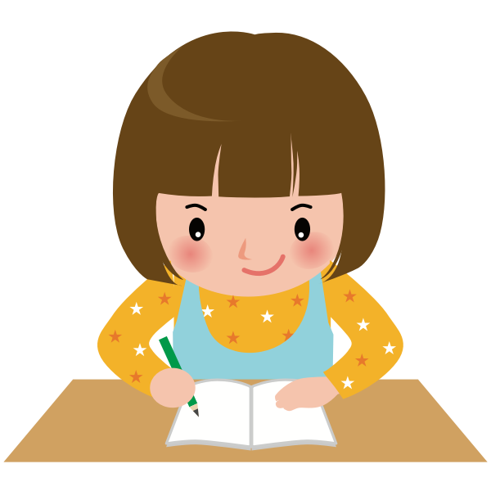

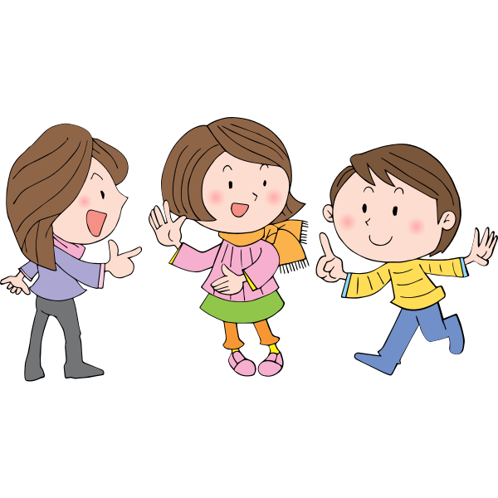

In Maths we will be:
- One to one counting
- Comparing amounts
- Learning about the composition of numbers
- Recognising numbers to 10 and 20
- Investigating mass and capacity
- Adding 2 numbers
- Learning about and using language linked to length and height
- Time and the vocabulary associated with it- then, next, later, yesterday, today and tomorrow and sequencing events in their lives.
- Learning number bonds to 10
- Naming and exploring the properties of 3D Shapes
- Exploring and creating more complex repeated patterns.
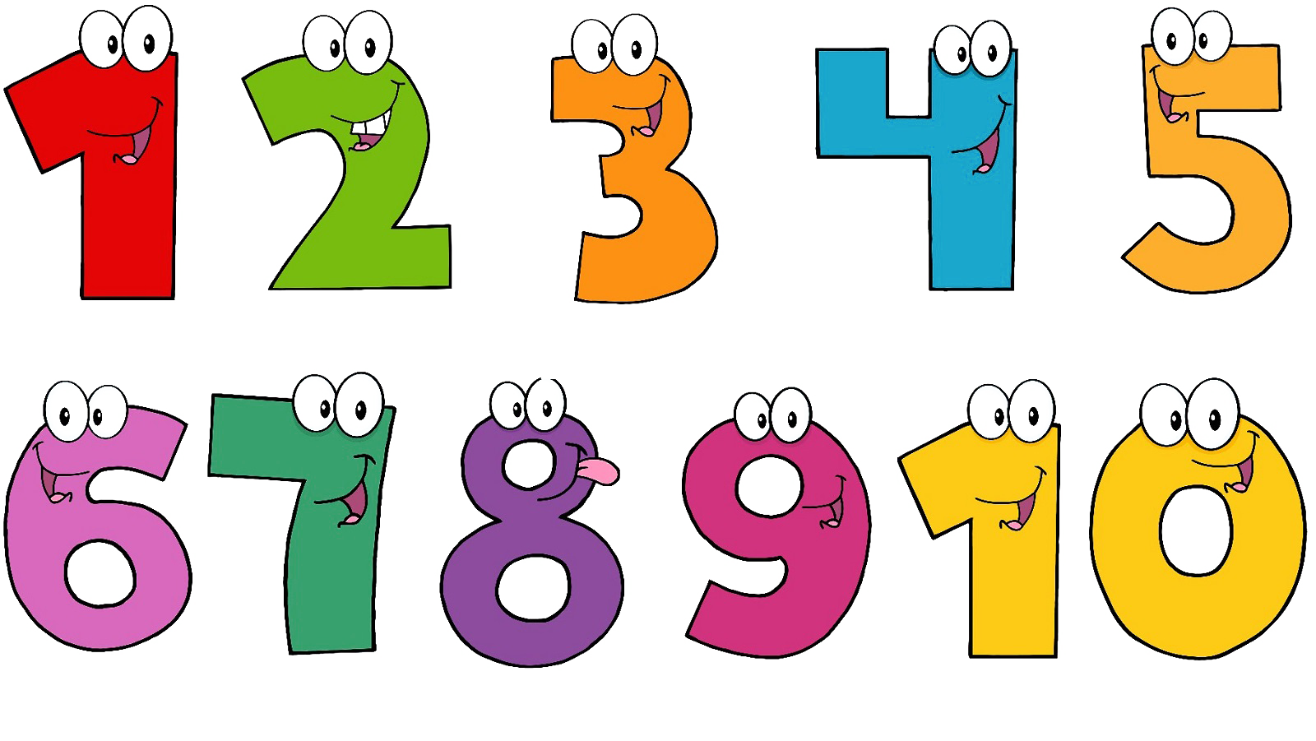

In Understanding the World we will be:
- Learning about different celebrations and the traditions associated with them; Chinese New Year, Mother’s Day; Shrove Tuesday and Easter.
- Set up a Chinese takeaway role play area.
- Focusing on the settings and environments in the stories we have shared
- Creating and following Pirate maps to find treasure.
- Using the mud kitchen to create Witch and Wizard potions and recipes.
- Programming and using the beebots to move from one point to another on a map.
- Exploring plants and growth by caring for plants
- Learning about composting and how it is used to help plants grow.
- Exploring exotic foods and tasting them.
- Planting bean seeds and observing how they grow.
- Planting potatoes and learning about how they grow.


Help at Home

- Practise writing your child’s name
- Support with reading at least three times a week, daily if possible.
- Completing the weekly learning tasks on Seesaw.
- Help learn Phase 2 and Phase 3 phonic sounds.
- Promote independent skills e.g. putting on own coats, personal self-care.

In Expressive Arts and Design we will be:
- Designing superhero costumes and masks.
- Creating hero vegetables linked to Supertato
- Making Mother’s Day cards
- Learning songs linked to growing
- Observational drawings of different fruits and vegetables using pastels and paint.
- Creating collages of different fruit and vegetables.
- Printing with different vegetables.
- Using a greater range of tools and equipment
- Learning new songs and rhymes
- Making magic wands from natural materials
- Designing and making pants for the aliens
- Making broomsticks from natural materials.
- Making telescopes by learning to join materials
- Create art work based on Winnie the witch using paint, chalk and oil pastels.

