THE WILLOWS PRIMARY SCHOOL

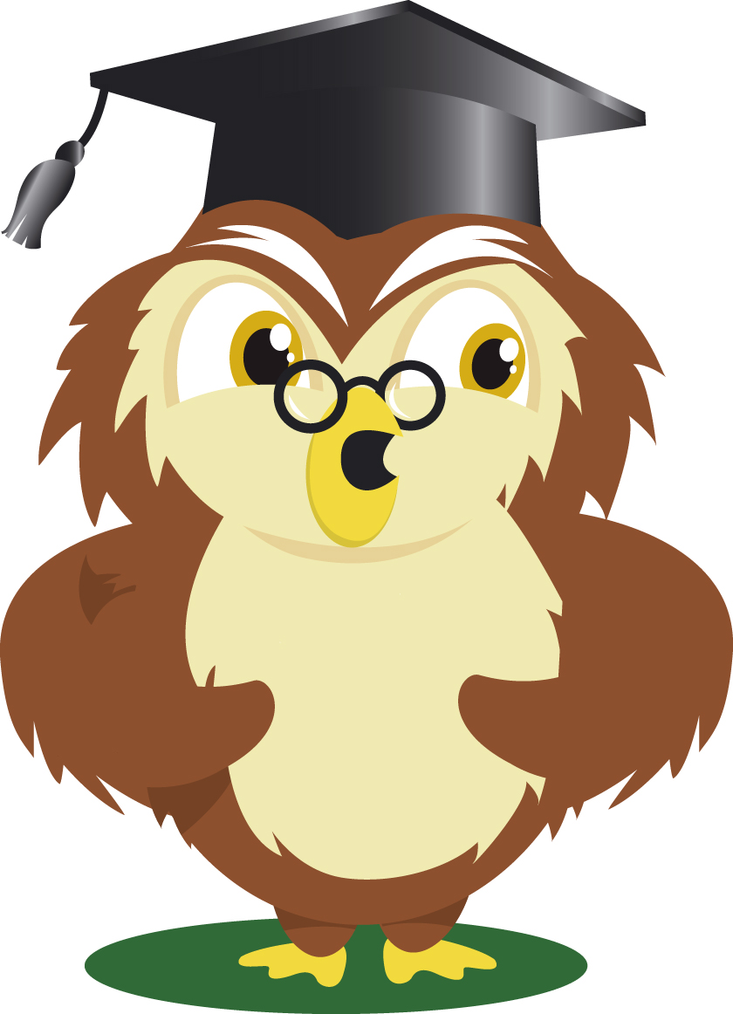

ART & DESIGN POLICY

Safeguarding Statement

The school is committed to safeguarding children and promoting the welfare of children and young people and expects all staff and volunteers to share this commitment.

Author: Art & Design Subject Leader

Date: September 2021

Review Date: September 2023

Signed :
Intent

The study of art includes learning about a range of media and styles: sculpture, collage, painting, photography, architecture, fashion & textiles, drawing, video and animation, printmaking and design.

As a result of our art curriculum, learners will be able to work with a range of materials/resources including wood, plastic, paper, yarn, clay, fabric, paint, crayon, pastel, charcoal, ink, computer programs and recycled and natural found materials to create visual art. Learners will develop their knowledge and understanding of a diverse range of artworks and artists from first-hand experiences and other sources, representing a variety of styles and created using a broad range of materials/media.

Children will be able to view objects of art and use their observation skills to evaluate, create or recreate. Learners will develop an understanding of the reasons for the creation of art, sources of inspiration and how the creative process works for different artists. Learners will also develop an understanding of the difference between copying, being influenced by, and being inspired by other artists or art works.

Teaching and learning in art is enriched by our focus on international learning. Children will experience and investigate the work of artists, craftspeople and designers from different cultures, including those represented in the home and host countries

Our aspiration is that children are inspired to be creative and use their imagination and experimentation to express ideas, emotions, observations and experiences in the form of artwork both in and out of school.

To be successful, learners must:
- rehearse, plan and refine ideas and record observations as part of the process of working towards their finished artwork
- Use colour, form, texture and patterns to develop their skills of drawing, painting, 3D modelling, printmaking and digital art with a range of materials
- Develop the confidence to explore, take risks and be reflective about their own work and that of others
- Understand, appreciate, respect and enjoy other people’s visual expressions
- Explore the use of the visual arts in people’s lives now and in the past, developing their knowledge of great artists, architects and designers
- Use appropriate vocabulary and subject-specific terminology in order to articulate and communicate ideas, opinions and feelings about their own work and that of others
- Connect learning within different aspects of art and between art and other subjects (e.g. design technology and history

Implementation
EYFS Expressive Arts and Design
The development of children’s artistic and cultural awareness supports their imagination and creativity. It is important that children have regular opportunities to engage with the arts, enabling them to explore and play with a wide range of media and materials. The quality and variety of what children see, hear and participate in is crucial for developing their understanding, self-expression, vocabulary and ability to communicate through the arts. The frequency, repetition and depth of their experiences are fundamental to their progress in interpreting and appreciating what they hear, respond to and observe.
Toddlers and young children will be learning to:  - Notice patterns with strong contrasts and be attracted by patterns resembling the human face.  - Start to make marks intentionally.  - Explore paint, using fingers and other parts of their bodies as well as brushes and other tools.  - Express ideas and feelings through making marks, and sometimes give a meaning to the marks they make. | 3 and 4-year-olds will be learning to:  - Create closed shapes with continuous lines and begin to use these shapes to represent objects.  - Draw with increasing complexity and detail, such as representing a face with a circle and including details.  - Use drawing to represent ideas like movement or loud noises.  - Show different emotions in their drawings and paintings, like happiness, sadness, fear, etc.  - Explore colour and colour mixing.  - Show different emotions in their drawings – happiness, sadness, fear, etc.
Children in reception will be learning to:
- Explore, use and refine a variety of artistic effects to express their ideas and feelings.
- Return to and build on their previous learning, refining ideas and developing their ability to represent them.
- Create collaboratively, sharing ideas, resources and skills.

Y1 | Drawing | Shape drawing (KANDINSKY) | Mark making | Small drawing skills (natural objects) – 2B pencils
Y1 | Colour | Colour mixing – primary and secondary colours | Colour mixing – manipulating watercolour pencils and paint, learning the “wet” technique | Colour – oil pastels (GEORGIA O’KEEFE)
Y1 | Focus | Simple printing  Natural sculptures – 3D work  ANDY GOLDSWORTHY | Wax resist and water colour seascapes | 3D work – clay  Making birds’ nests
Y2 | Drawing | Mark making – introducing a range of drawing pencils | Mark making – looking at how artists use different styles of mark making (VAN GOGH) | Let’s draw small – introducing light and shade and recording tone
Y2 | Colour | Colour mixing – exploring tone/light/dark | Mark making with colour – felt tips, pencils  LICHENSTEIN | Working with chalk pastels  Bubbles activity, drawing spirals, creating skin tone
Y2 | Focus | Portraiture – portraits and self-portraits  PICASSO and MODIGLIANI | Textiles – weaving (IKAT designs Cambodia)  Printing – foam board technique | 3D work – Making clay tiles, using templates to cut pieces and slip to add relief

Y3 | Drawing | Continuous line drawing  Mini project – drawing feathers | Showing light and dark and casting shadow  Drawing by touch and feel | 3D drawing – using charcoal and chalk to create light and shadow
Y3 | Colour | Mixed media | Learning to use coloured inks with the “dry” technique | Using watercolour pencils – 3D effects
Y3 | Focus | Aboriginal Art – dreamtime paintings  CLIFFORD POSSUM TJAPALTJARRI | Egyptian wall paintings | 3D work – papier mâché  CLAES OLDENBURG
Y4 | Drawing | Proportions and position of features on a face | Human form and proportion | Still life drawing – plants, fruit
Y4 | Colour | Skin tone | Exploring backgrounds | Colour collage - MATISSE
Y4 | Focus | String Printing | 3D work – clay  ALBERTO GIACOMETTI  BARBARA HEPWORTH | Tiger in a tropical storm  HENRI ROUSSEAU
Y5 | Drawing | Drawing skills – drawing transparent and translucent materials | Drawing Greek vases, exploring shapes, patterns and using images/paper cut outs | Drawing skills Mehndi patterns
Y5 | Colour | Colour work – using watercolours and pastels to represent glass | Wax and watercolour | Colour work- detail using viewfinders
Y5 | Focus | Textiles – collage including sewing  VAN GOGH Starry Night | 3D work – clay  Clay slab work using an armature | Comparing work of different artists creating rivers  MONET, HUDSON RIVER SCHOOL, JMW TURNER
Y6 | Drawing | Drawing buildings and scenes – vanishing points  LEONARDO DA VINCI  CEZANNE | Drawing skills – life drawing. Fruit and veg | Anime characters
Y6 | Colour | Colour work – colour detailing | Colour Work – abstract designs and patterns  CARLOLEE S. CLARK | Colour work – Japanese brush and ink work
Y6 | Focus | 3D work – clay, sewing, casting, wore work  Crating a Roman artefact museum | Colour work/collage Political Art  BANKSY, WILLIE BESTER | Digital Photography/Collage  ANSELL ADAMS - Beauty to destruction

Time and Organisation
Art is taught as part of the International Primary Curriculum and the learning goals for this subject are integrated into the topics covered. Pupils also have an opportunity to develop an understanding of the subject as a whole through discrete skills sessions. Pupils are taught in groups and as a class, according to the nature of the learning task.

- KS1 pupils will follow the Milepost 1 learning goals
- LKS2 pupils will follow the Milepost 2 learning goals
- UKS2 pupils will follow the Milepost 3 learning goals

Special Needs and Classroom Support
Appropriate differentiated provision is planned by teachers to accommodate individual needs.

Pupils’ Record of Their Work
Pupils’ independent and group work can be recorded in a variety of ways relevant to the type and purpose of the activity. This includes the use of photos, IPADs and other media as well as recording work in their individual sketchbooks.

Monitoring and Assessment
Pupils will be monitored both individually and in groups depending on the specific activities they will be undertaking. Children are encouraged to discuss their own projects and progress in pairs or groups or as a class and are given oral feedback from their peers and their teachers. Good examples of work are demonstrated and discussed with the class. Displays, both permanent and transitory, celebrate good art work around the school and praise assemblies include art achievements.

Assessment techniques used include observation, teacher assessment of their artwork, practical tasks and discussion. Their knowledge, skills and understanding will be assessed and recorded against the IPC learning goals for this subject. This information will form part of the annual report to parents at the end of each academic year.

Resources
Each class has access to a sink and is equipped with a basic set of art equipment.
Each team has access to specialist equipment in their own area.
Resources relating to artists are located in the library.
Teachers have access to ICT software and graphics packages.
Internet sites are used to support research and background information.
We provide artefacts for still-life drawing and the school grounds are used for stimulus
and inspiration.

Outdoor Learning and Trips
Our art curriculum is enriched by trips, workshops, visits and visiting artists wherever possible. School trips and visits allow pupils to encounter experiences that are unavailable in the classroom. They can help pupils to develop knowledge and skills within a growing awareness and understanding of artwork and artists.

THE WILLOWS PRIMARY SCHOOL

SUBJECT LEADER
Roles & Responsibilities

To monitor the subject and be able to comment on
- Standards throughout the school
- Progression of skills throughout the school
Gather evidence on the quality of provision within the subject through monitoring/evaluation
- Lesson observations/learning walks
- Work/book scrutiny
- Planning scrutiny
- Pupil/staff discussion
Monitoring activities must be agreed with HT before they take place and feedback from these activities should be discussed and agreed with HT before it is given to staff
To be able to identify the quality of provision in the subject
- Know the strengths and weaknesses of the subject
- Know the development priorities for the subject as detailed in the SDP
- Know how the SDP priorities for the subject are being addressed
To develop secure subject knowledge and keep up to date with developments in the subject from EYFS, through KS1 and across KS2
To audit and maintain subject specific resources so that the subject can be successfully delivered throughout the school
- Order replacement/new resources in liaison with HT
Report on your subject to the HT
- Verbally at meetings, when requested
- Through the end of year co-ordinator report
Co-ordinate Governor visits, when requested, following liaison with the HT
Maintain CPD of yourself and other staff with a focus on your subject area
- Feedback to other staff on CPD undertaken
- Lead staff meetings and plan INSET when requested
Maintain the subject policy for the school
- Review the policy as per the policy review schedule
- Liaise with staff in terms of reviewing the policy – amend/distribute the policy accordingly
To advise and assist staff with the teaching and learning of the subject
Maintain a Subject Leader file
In line with HT management of teacher workload, subject leaders should not request additional work from staff unless agreed by HT beforehand

Appendix 1 – National Curriculum Requirements for Art & Design
The national curriculum for art and design aims to ensure that all pupils:
♣ produce creative work, exploring their ideas and recording their experiences
♣ become proficient in drawing, painting, sculpture and other art, craft and design techniques ♣ evaluate and analyse creative works using the language of art, craft and design
♣ know about great artists, craft makers and designers, and understand the historical and cultural development of their art forms.
By the end of each key stage, pupils are expected to know, apply and understand the matters, skills and processes specified in the relevant programme of study.
Key stage 1
Pupils should be taught:
♣ to use a range of materials creatively to design and make products
♣ to use drawing, painting and sculpture to develop and share their ideas, experiences and imagination
♣ to develop a wide range of art and design techniques in using colour, pattern, texture, line, shape, form and space
♣ about the work of a range of artists, craft makers and designers, describing the differences and similarities between different practices and disciplines, and making links to their own work.
Key stage 2
Pupils should be taught to develop their techniques, including their control and their use of materials, with creativity, experimentation and an increasing awareness of different kinds of art, craft and design.
Pupils should be taught:
♣ to create sketch books to record their observations and use them to review and revisit ideas ♣ to improve their mastery of art and design techniques, including drawing, painting and sculpture with a range of materials [for example, pencil, charcoal, paint, clay]
♣ about great artists, architects and designers in history

Appendix 2 – IPC Learning Goals for Art
