

Equality information and objectives
September 2022

- Our commitment to equalities and community cohesion
- Part 1: How we have due regard for equality
- Part 2: Information about the pupil population
- Part 3: Consultation and Engagement
- Part 4: Our main equality challenges
- Part 5: Our Equality objectives
- Appendix 1 – Pupil Disability Questionnaire
- Appendix 2 – Parent/Staff Disability Questionnaire

- Updated in Feb 2023
- To be updated in July 2023

To be reviewed – Dec 2023

Our school commitment
The Equality Act 2010 requires us to publish information that demonstrates that we have due regard for the need to:
- Eliminate unlawful discrimination, harassment, victimisation and any other conduct prohibited by the Equality Act 2010
- Advance equality of opportunity between people who share a protected characteristic and people who do not share it
- Foster good relations between people who share a protected characteristic and people who do not share it.

At The Willows Primary School:
- We try to ensure that everyone is treated fairly and respectfully
- We want to make sure that our school is a safe and secure place for everyone
- We recognise that people have different needs, and we understand that treating people equally does not always involve treating them the same
- We aim to make sure that no-one experiences less favourable treatment or discrimination because of:
- Their age
- A disability
- Their ethnicity, colour or national origin
- Their gender
- Their gender identity (if they have reassigned or plan to reassign their gender)
- Their marital or civil partnership status
- Their being pregnant or having recently had a baby
- Their religion or belief
- Their sexual identity and orientation.
- We recognise that some pupils need extra support to help them to achieve and be successful
- We try to make sure that people from different groups are consulted and are involved in our decisions, especially pupils, parents/carers and those of us who can be treated less favourably.

We welcome our duties
  - To promote community cohesion (under the Education and Inspections Act 2006)
  - To eliminate discrimination, advance equality of opportunity and foster good relations (under the Equality Act 2010)

We also welcome the emphasis of Ofsted inspections on the importance of accelerating the progress of pupils from groups who are underachieving.

As part of this we will:
- Publish information every year about our school population
- Outline how we have due regard for equality (of treatment and opportunity) and how we promote community cohesion
- Publish equality objectives to show how we plan to tackle particular inequalities and improve what we do

For more information please contact: Jo MacArthur (Headteacher) or Huw Griffiths (Member of governing body with responsibility for equality issues) at the school Tel:01635 42155 Email: Office@willows.w-berks.sch.uk

Part 1: How we have due regard for equality
The information provided here aims to show that we give careful consideration to equality issues in everything that we do in the school.

We are committed to working to ensure equal treatment of and the equality of opportunity for all our pupils. To meet our duty to have due to regard to the need to eliminate unlawful discrimination, harassment and victimisation and other conduct towards pupils with protected characteristics (age, disability, gender reassignment, marriage and civil partnership, pregnancy and maternity, race, religion or belief, gender, and sexual orientation)

We expect all members of the school community and visitors to support our commitment to promoting equalities and meeting the requirements of the Equality Act. We will provide training, guidance and information to enable them to do this.

Governing body
The governing body is responsible for ensuring that the school complies with legislation, and that this policy and its related procedures and action plans are implemented. A designated member of the governing body has responsibility for quality issues and the implementation of this policy. Governors bi-annually review the Equality Statement and evaluate the success of the school’s Equalities Work

Headteacher and Leadership team
The Headteacher is responsible for implementing the policy; for ensuring that all staff are aware of their responsibilities and are given appropriate training and support; and for taking appropriate action in any cases of unlawful discrimination.

Teaching and Support Staff
All teaching and support staff will:
- promote an inclusive and collaborative ethos in their classroom
- challenge prejudice and discrimination
- deal fairly and professionally with any prejudice-related incidents that may occur
- plan and deliver a curriculum and lessons that reflect the school’s principles, for example, in providing materials that give positive images in terms of race, gender and disability
- maintain the highest expectations of success for all pupils
- support different groups of pupils in their class through differentiated planning and teaching, especially those who may (sometimes temporarily) find aspects of academic learning difficult
- keep up-to-date with equalities legislation relevant to their work.

We will provide training and guidance on Equalities for all staff new to the school as part of the induction procedure. We will go through the principal expectations and duties of the Equality Act at a whole staff meeting at the start of the school year. Staff will receive a certificate of attendance.

Number of staff employed by the school: 60
We currently do not collect information from employees in relation to some protected characteristics, such as gender identity and sexual orientation. However we are aware that there may be equality issues for gay, lesbian and bisexual staff, as well as those who are undergoing or who have undergone a reassignment of their gender.

- No data about the sexual orientation of pupils, parents or staff is collected or held by the school.
- No data is collated by the school about gender reassignment for the pupil or staff population

Visitors
All visitors to the school, including parents and carers are expected to support our commitment to equalities and comply with the duties set out in this policy.

Disability
We are committed to working for the equality of people with and without disabilities
All sections of the building are accessible to staff, governors, parents and pupils via the ramps and wide entrance doors. Disabled car parking has been demarcated for disabled drivers’ use.
To meet our duties under the Equality Act 2010 we show we have due to regard to the need to  Advance equality of opportunity by: | We support disabled learners by meeting their individual needs, through meeting with parents/ carers and with specialists to draw up individual support plans. These needs are then cascaded to all staff who come into contact with the child to ensure their needs are fully met.  The school would always consider applications from and interview disabled applicants meeting the person specification for any advertised post.
To meet our duties under the Equality Act 2010 we show we have due to regard to the need to  Foster good relations and community cohesion by: | The school promotes the spiritual, moral, social and cultural development of all pupils. We ensure that the curriculum has positive images of disabled people. Pupils and visitors are fully included in all aspects of school life regardless of any disability.
What has been the impact of our activities?
Pupils see other people, particularly those with disabilities, as equals

Ethnicity and race (including EAL learners)
We are committed to working for the equality of all ethnic groups.
In the academic year 2018/19 there were no racial incidents recorded or reported.
To meet our duties under the Equality Act 2010 we show we have due to regard to the need to  Advance equality of opportunity by: | We regularly monitor the attainment and progress of all our EAL pupils and take actions to address any negative trends that may materialise.
To meet our duties under the Equality Act 2010 we show we have due to regard to the need to  Foster good relations and community cohesion by: | We ensure that the curriculum has positive images of people from a range of ethnic backgrounds. All ethnic groups represented in our school community play an active role in the life of the school.
What has been the impact of our activities?
Pupils see other people, particularly those from other ethnic backgrounds, as equals.

Gender
We are committed to working for the equality of women and men.
Pupil roles in school such as house captains, school council members and monitors are an equal balance of male and female pupils. The staff population is significantly more female than male but we do have 4 male teaching staff 2 male teaching assistants, 2 male sports coaches and 1 male caretaker employed.
To meet our duties under the Equality Act 2010 we show we have due to regard to the need to  Advance equality of opportunity by: | We regularly monitor the attainment and progress of all our pupils by gender and take actions to address any negative trends that may materialise.
To meet our duties under the Equality Act 2010 we show we have due to regard to the need to  Foster good relations and community cohesion by: | We ensure that the curriculum has positive images of people, male and female. We invite a variety of groups/speakers into school to assist us in promoting aspiration among our pupils.
What has been the impact of our activities?
Pupils see other people, male or female, as equals

Religion and Belief
We are committed to working for the equality for people based on their religion, belief and non-belief.
Pupils of all faiths are provided with opportunities to share their faith practices and experiences. LA guidelines are followed should parents wish to exercise their right to withdraw their child from collective worship.
To meet our duties under the Equality Act 2010 we show we have due to regard to the need to  Advance equality of opportunity by: | The school supports our pupils to build their sense of identity and belonging, helping them to flourish within their communities and as citizens in a diverse society.
To meet our duties under the Equality Act 2010 we show we have due to regard to the need to  Foster good relations and community cohesion by: | The curriculum makes good provision for the teaching of other faiths across the school in line with the locally agreed syllabus. The children have opportunities to visit places of worship and listen to speakers from other faith groups.
What has been the impact of our activities?
Pupils understand and respect the authenticity and value of the beliefs of others.

Age (in relation to staff only)
We are committed to working for the equality of people of all ages.
We believe in providing good quality education for all pupils regardless of race, sex, ethnic or national origin, or special educational needs. It is equally our intention that recruitment, selection, training and promotion of staff are based solely on the criteria of merit and ability and that no employee or putative employee will be subject to any of the adverse discriminators listed above, nor will they receive less favourable treatment on the grounds of marital status, domestic circumstances, age, sexuality, disability, trade union activity, political views or religious beliefs.
To meet our duties under the Equality Act 2010 we show we have due to regard to the need to  Eliminate unlawful discrimination by: | Ensuring that the age of candidates is not generally taken into account during the selection process – neither at the shortlisting stage nor in the later interview process
What has been the impact of our activities?
There are no plans to change the recruitment process. This will be regularly reviewed to ensure compliance.

Marriage and Civil Partnership (in relation to staff only)
We are committed to working for the equality of people regardless of their martial status or home circumstances.
When information about changes in marital status or home circumstances are communicated to school they are recorded on the database. No data is collated by the school about staff or parents’ marital status, apart from names given for home contact and information about whether letters home/ reports are to be duplicated and sent to two addresses or details of next of kin for staff members.
To meet our duties under the Equality Act 2010 we show we have due to regard to the need to  Eliminate unlawful discrimination by: | Selection criteria for posts do not include reference to the marriage or civil partnership status of candidates. This is not taken into account during the selection process and interviewers are precluded from asking questions about this during the interview process.
What has been the impact of our activities?
There are no plans to change the recruitment process. This will be regularly reviewed to ensure compliance.

Pregnancy and maternity
The school endeavours to meet the requests of staff returning to work following maternity leave and where appropriate offers flexible arrangements regarding emergencies relating to children, childcare and parenting.

Part 2: Information about the pupil population
Number of pupils on roll at the school: 404 (Feb 2023) – 189 girls and 215 boys

Information on pupils by protected characteristics
The Equality Act protects people from discrimination on the basis of ‘protected characteristics’. Every person has several of the protected characteristics, so the Act protects everyone against unfair treatment. These are age, disability, gender reassignment, marriage and civil partnership, pregnancy and maternity, race, religion or belief, gender, and sexual orientation.

Disability
The Equality Act defines disability as when a person has a “physical or mental impairment which has a substantial and long term adverse effect on that person’s ability to carry out normal day to day activities.”

Number of pupils with disabilities - these numbers are typically very low, so the school feels it would be inappropriate to publish this information. Less than 10 parents returned questionnaires that indicated they believe their child/children to be disabled

There are no disabled members of staff.

Sensitive information on some pupils with protected characteristics
Some information in relation to protected characteristics we regard as sensitive.
It is not appropriate for us to collect information from pupils in relation to some protected characteristics, such as gender identity and sexual orientation.

Gender Reassignment - No data is collected by the school about gender reassignment for the pupil or staff population.

Sexual orientation - No data about the sexual orientation of pupils, parents or staff is collected or held by the school.

Information on other groups of pupils
Ofsted inspections of schools will look at how schools help "all pupils to make progress, including those whose needs, dispositions, aptitudes or circumstances require additional support."

In addition to pupils with protected characteristics, we wish to provide further information on the following groups of pupils:

Looked after children - This includes children ceased to be looked after through adoption, special guardianship, residence order or child arrangement order – 14 children

Special Educational Needs (SEND) | Number of pupils | Percentage (%) of school population
No Special Education Need | 362 | 84%
SEND support (K) | 62 | 14%
EHCp | 6 | 1%
Total SEN | 68 | 16%

English as an additional language (EAL) |  |  | Total | % of school population
Number of pupils who speak English as an additional language |  |  | 70 | 16%
Number of pupils who are at an early stage of English language acquisition |  |  | 12 | 3%
Pupils on roll by their first language | TOTAL
Arabic | 2
Benagli | 2
English | 360
Gujarati | 1
Hindi | 7
Kannada | 1
Kurdish | 3
Lithuanian | 4
Marathi | 2
Polish | 20
Portugese | 6
Romani (International) | 1
Romanian | 6
Russian | 1
Tamil | 1
Telegu | 5
Turkish | 3
Urdu | 3
Vietnamese | 2

Pupils from low income households | Total | Percentage of school population
Number of pupils currently eligible for free school meals | 83 | 19%
Number of pupils on roll who have been eligible for free school meals in the last six years (Pupil Premium applies to this group from September 2012) | 109 | 25%

Universal Infant School Meals
National Curriculum Year Group | Number of pupils on roll | Of which
National Curriculum Year Group | Number of pupils on roll | School lunch taken on census day | Currently FSM eligible on census day
Reception | 48 | 30 | 7
Year 1 | 60 | 39 | 14
Year 2 | 58 | 45 | 16

Children with poor attendance including persistent absentees (below 90% attendance) | 2019 Spring Term
Number of pupils with at least 1 absence in 2019 spring term | 224
% of pupils with at least one absence in 2019 spring term | 70.22%
Total possible sessions for all pupils | 37080
Total sessions missed due to authorised absence for all pupils | 1269
Authorised absence as a % of total sessions possible | 3.42%
Total sessions missed due to unauthorised absence for all pupils | 411
Unauthorised absence as a % of total sessions possible | 1.11%
Total sessions missed due to overall absence for all pupils | 1680
Overall absence as a % of total sessions possible | 4.53%
Number of pupils identified as persistent absentees | 44
% of pupils identified as persistent absentees | 13.79%

Other vulnerable groups - Young Carers, Children subject to social services involvement through CIN (Child in Need) or CP (Child Protection) plans and less able children with no identified SEN
Part 3: Consultation and engagement
We aim to engage with and consult with pupils, staff, parents and carers, the local community so we can improve our information, learn about the impact of our policies, develop our equality objectives and improve what we do.

Our main activities for consulting and engaging are:
- Disability Questionnaire – completed annually by pupils, parents, staff and governors.
- Promotion of relevant information on the school website
- RSHE curriculum in school for all children

Record of consultation and engagement
Date | Who we consulted | Summary | Action taken
May 2019 | Pupils, parents, staff, governors, regular visitors | Data collated and analysis published (see below) | Review pupil understanding of disability  Review anti-bullying/equality/diversity messages as part of PSHE lessons and assemblies  Publicise equality statement on website and ways in which we fulfil our duty.
Jan 22 | Pupils, parents, staff | Data collated and analysis published (see below) | Complete new Accessibility plan for the school  Publicise equality statement on website and ways in which we fulfil our duty.

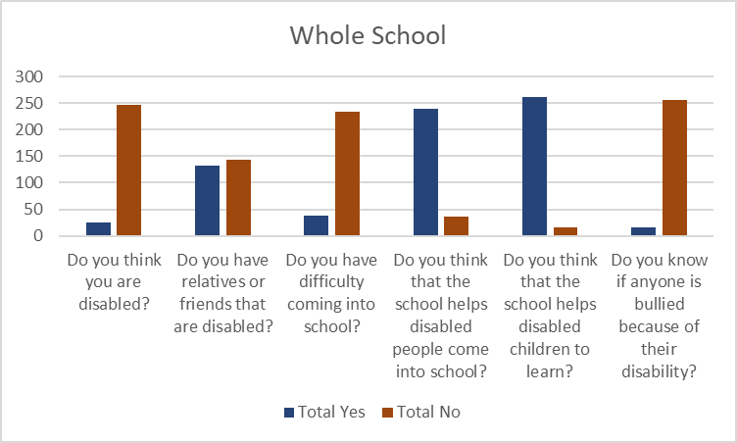

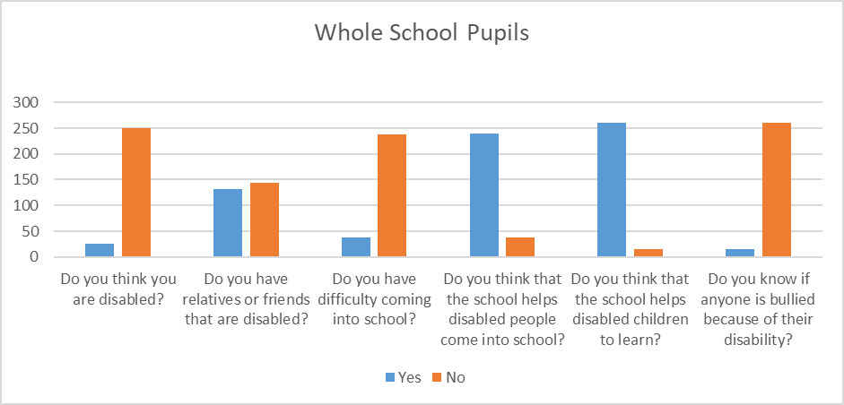
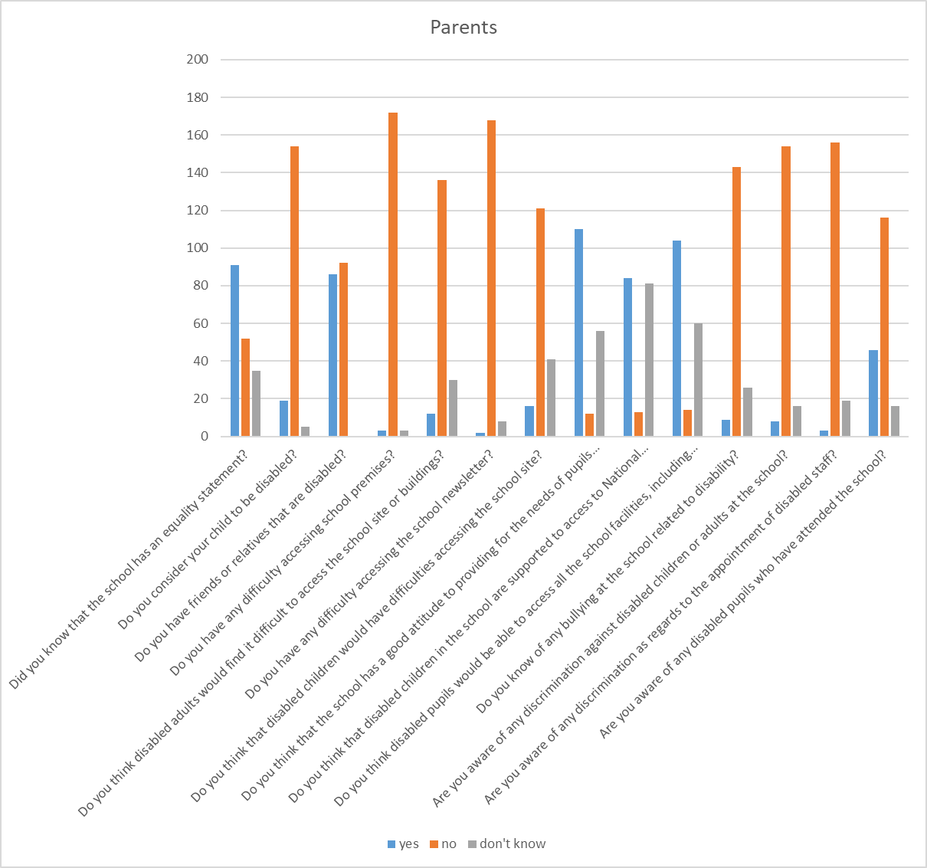

Part 4: Our main equality challenges
This is a summary of the issues that we are most concerned about. We are already developing strategies and activities to address some of these challenges, and details are provided in Part 3 below. For some of these challenges we have also set and published equality objectives. See Part 6 of this document.

We see our main challenges as the achievement and engagement of
- EHCp pupils and those with special educational needs
- Dual needs FSM/PPG pupils
- Low ability pupils with no identified SEN
- EAL pupils in the early stages of language acquisition
- Achievement and engagement of pupils with below 90% attendance (persistent absentees)

Part 5: Our equality objectives
The Equality Act 2010 requires us to publish one or more specific and measurable equality objective. We aim to address areas where we need to take action to improve equality and tackle disadvantages. We will regularly review the progress we are making to meet our equality objectives.

Equality objective 1:
To raise the attainment and improve the progress of PPG/disadvantaged pupils in English & Maths and close gap between disadvantaged and non-disadvantaged children

Progress we are making on this objective:
Progress Update Feb 2023

Progress Update July 2023

Final Summary of Progress Dec 2023

Policy to be reviewed and updated Dec 2023

Equality objective 2:
To ensure that EAL learners are appropriately supported in their learning to ensure that their level of language acquisition is not a barrier to their achievement

Progress we are making on this objective:
Progress Update July 2019
July 2019 |  | Reading | Writing | Maths
Whole school | On Track to achieve EXS+ | 67% achieved ARE  (246/369 pupils) | 60% achieved ARE  (221/369 pupils) | 64% achieved ARE  (237/369 pupils)
Whole school EAL pupils | On Track to achieve EXS+ | 68% (44/65 pupils) | 69% (45/65 pupils) | 75% (49/65 pupils)

Progress Update July 2020
At the end of the academic year – 17% of the school population (Year R – Y6) were PPG – a total of 65 pupils. This is an increase of 3 pupils since the start of the academic year.

March 2020 |  | Reading | Writing | Maths
Whole school | On Track to achieve EXS+ | 74% (276/373 pupils) | 71% (263/373 pupils) | 77% (289/373 pupils)
Whole school EAL pupils | On Track to achieve EXS+ | 80% (52/65 pupils) | 78% (51/65 pupils) | 86% (56/65 pupils)

End of spring term data was the last assessment point of this academic year as a result of lockdown/school closure. The above data shows that the EAL pupils, as a group, are performing better than the whole school average in terms of the number on track to achieve ARE. Since the end of last academic year, the achievement of EAL pupils has increased by 12% in reading, 9% in writing and 11% in maths.

Final Summary of Progress Dec 2021

Policy to be reviewed and updated Dec 2021

Equality objective 3:
To raise the attainment of less able pupils with no identified SEND in English and Maths.
Target revised - To raise the attainment of all pupils with no identified SEND in English and Maths.

Progress we are making on this objective:
Pupils who are not on track to achieve ARE but are not SEND are monitored as a group at pupil progress meetings. Each pupil is discussed in terms of the gap between their current attainment and ARE in R, W and Ma. Venn diagrams show all pupils who are not on track but those with no SEND are highlighted separately to those with SEND.
Data is monitored in terms of the whole school picture and our intention to continually increase the number of children achieving ARE year on year.

Progress Update July 2020
July 2019 |  | Reading | Writing | Maths
Whole school | On Track to achieve EXS+ | 67% achieved ARE  (246/369 pupils) | 60% achieved ARE  (221/369 pupils) | 64% achieved ARE  (237/369 pupils)
March 2020 |  | Reading | Writing | Maths
Whole school | On Track to achieve EXS+ | 74% (276/373 pupils) | 71% (263/373 pupils) | 77% (289/373 pupils)

End of spring term data was the last assessment point of this academic year as a result of lockdown/school closure. The above data shows that since the end of last academic year, the achievement of all pupils has increased by 7% in reading, 11% in writing and 13% in maths
Final Summary of Progress Dec 2021

Policy to be reviewed and updated Dec 2021

Equality objective 4:
To improve attendance of the children who are currently persistent absentees (below 90% attendance)

Progress we are making on this objective:
Progress Update July 2019
July 18 | 63 PERSISTENT ABSENTEES | 18% of whole school cohort
Dec 18 | 27 PERSISTENT ABSENTEES | 8% of whole school cohort
April 2019 | 34 PERSISTENT ABSENTEES | 11% of whole school cohort
July 2019 | 22 PERSISTENT ABSENTEES | 7% of whole school cohort
Persistent absentees reduced by 11 % which equates to 41 children.

Progress Update July 2020
July 18 | 63 PERSISTENT ABSENTEES | 18% of whole school cohort
Dec 18 | 27 PERSISTENT ABSENTEES | 8% of whole school cohort
April 2019 | 34 PERSISTENT ABSENTEES | 11% of whole school cohort
July 2019 | 22 PERSISTENT ABSENTEES | 7% of whole school cohort
Dec 19 | 40 PERSISTENT ABSENTEES | 11% of whole school cohort
March 20 | 61 PERSISTENT ABSENTEES | 16% of whole school cohort

In December 2019, there was slight rise in the % of children who were persistently absent from school (+4%). This was a result of poor attendance in the Reception class of non-statutory school aged children (below 5yrs) and a number of periods of unauthorised holiday absence – the school and governors applied fixed penalty notice sanctions.

A further increase in persistent absenteeism at the end of the Spring Term (March 2020) was a result of the start of the Coronavirus pandemic and periods of self-isolation.
Attendance monitoring for the remainder of the academic year was suspended in line with Government guidance.

Attendance policy was reviewed – May 2020 and new version published on website

Key actions for Sep – to send out updated attendance policy to all parents.
The government guidance says: ‘Missing out on more time in the classroom risks pupils falling further behind. Those with higher overall absence tend to achieve less well in both primary and secondary school. School attendance will therefore be mandatory again from the beginning of the autumn term.”
The above information was sent out to parents at the end of July 2020 in a newsletter.

Final Summary of Progress Dec 2021

Policy to be reviewed and updated Dec 2021

Appendix 1

The Willows Primary School
Disability Questionnaire for Children

Please circle your year group Y1 Y2 Y3 Y4 Y5 Y6

We would like to find out your views about disability. Some children and grown ups are disabled; for example, they might not be able to hear or see properly, they might use a wheelchair, or find it difficult to understand other people. We want to help disabled people at our school.

Do you think you are disabled? Yes No

Do you have relatives or friends that are disabled? Yes No

Do you have difficulty coming into school? Yes No

Do you think the school helps disabled people come
into school? Yes No

Do you think the school helps disabled children to
learn? Yes No

Do you know if anyone is bullied because of their disability? Yes No
(If yes please give details)

Thank you for taking the time to complete this questionnaire.

Appendix 2

