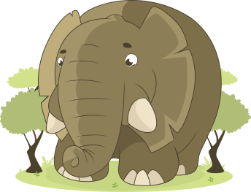
An elephant goes like this and that
https://www.youtube.com/watch?v=qg7l50NjKco
An elephant goes like this and that
He’s terribly big and he’s terribly fat
He’s got no fingers and he’s got no toes
But goodness gracious what a nose!

