Mathematics in Year 4
- Count backwards through zero to include negative numbers.
- Compare and order numbers beyond 1,000. Compare and order numbers with up to 2 decimal places.
- Read Roman numerals to 100.
- Find 1,000 more/less than a given number.
- Count in multiples of 6, 7, 9, 25 and 1000.
- Recall and use multiplication and division facts all tables to 12x12.
- Recognise the place value of any 4-digit number.
- Round any number to the nearest 10, 100 or 1,000.
- Round decimals with 1dp to nearest whole number.
- Add and subtract numbers with up to 4-digits using written columnar method.
- Multiply 2-digit by 1-digit and 3-digit by 1-digit
- Count up/down in hundredths.
- Recognise and write equivalent fractions. Add and subtract fractions with same denominator.
- Read, write and convert time between analogue and digital 12 and 24 hour clocks.

Y4 Addition | Y4 Subtraction
- Continue with columnar addition.  H T O 3 7 1 + 4 8 5 8 5 6 1 H T O 3 7 6 + 4 8 5 8 6 1 1 1 Th H T O 2 3 8 8 + 1 1 2 4 3 5 1 2 1 1  - Estimate and use inverse operations to check answers to a calculation.  - Add money using both £ and pence in practical contexts. | - Continue with partitioned columnar subtraction progressing to compact columnar subtraction.  H T O ³4¹3 7 - 1 8 2 2 5 5 H T O ³4 ¹² 3 ¹2 - 1 8 7 2 4 5 H T O ⁵6 ⁹¹0 ¹4 - 3 4 7 2 5 7 Th H T O 8 ³ 4 ¹¹2 ¹6 - 2 1 7 7 6 2 4 9  - Estimate and use inverse operations to check answers to a calculation.  - Subtract amounts of money using columnar method.

Y4 Multiplication
- Recall and use multiplication tables up to 12x12
(Including multiplying by 0 and 1).

- Continue using grid method and expanded method as appropriate, progressing to short multiplication.

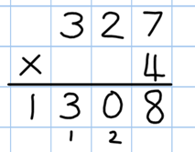
x | 100 | 30 | 6
5 | 500 | 150 | 30

- Short Multiplication.

No carrying  T O  3 2  x 3  9 6 | Extra digit  H T O  5 1  x 2  1 0 2 | Carrying  H T O  3 8  x 7  2 6 6  5 | Zeros  H T O  2 0 2  x 4  8 0 8 | Ext.  H T O  5  x 4  6 1 2  2 1

Y4 Division
- Recall and use all division facts for all tables up to 12 (Including dividing by 1).

- Continue with short division method.

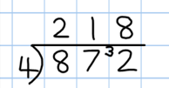
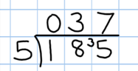
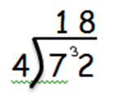

- Progressing to short division with remainders.

2 0 4  4) 8 1 ¹6 | 1 4 1 r1  3) 4 ¹2 4

