Mathematics in Year 6
- Use negative numbers in context and calculate intervals across zero.
- Compare and order numbers up to 10,000,000.
- Identify common factors, common multiples and prime numbers.
- Round any whole number to a required degree of accuracy.
- Identify the value of each digit to 3 decimal places.
- Use knowledge of order of operations to carry out calculations involving four operations.
- Multiply and divide - 4-digit by 2-digit
- Add and subtract fractions with different denominators and mixed numbers.
- Multiply simple pairs of proper fractions, writing the answer in the simplest form.
- Divide proper fractions by whole numbers.
- Calculate % of whole number.

Y6 Addition | Y6 Subtraction
- Add several numbers of increasing complexity using columnar addition.  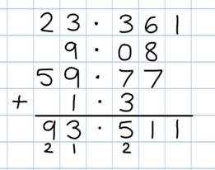  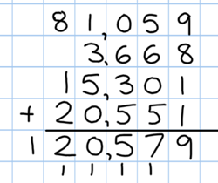 | - Continue with compact columnar subtraction, including subtraction of decimals.  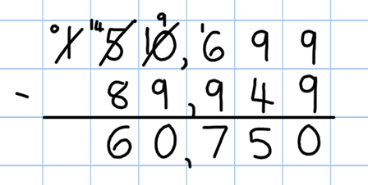  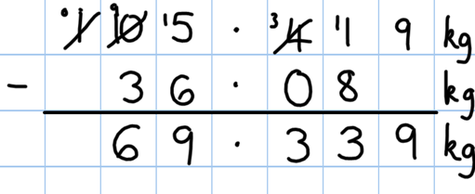  - Use estimation to check answers to calculations and to determine, in the context of a problem, levels of accuracy.

Y6 Multiplication | Y6 Division
• Recall and use multiplication tables up to 12x12  (Including multiplying by 0 and 1).  - Continue to practise short multiplication.  - Continue to practise long multiplication.  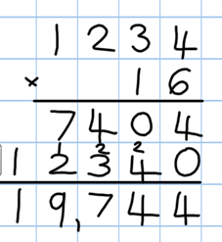  - Multiply decimals using the grid method and progressing on to short multiplication.  - Use estimation to check answers to calculations and determine, in the context of a problem, an appropriate degree of accuracy. | - Consolidate short division.  - Children should be able to interpret remainders as whole number remainders, fractions or by rounding, as appropriate for the context.  - Introduce long division.

